

Customer Retention- Analysis

Submitted by:

Amey Takle

**INTRODUCTION**

* Business Problem Framing

The task is to analyse the given data wrt to the male and female population

* Conceptual Background of the Domain Problem

This seems to be a binary classification problem considering analysis is to be done with respect to the gender column

* Motivation for the Problem Undertaken

Objective behind the problem is to help ecommerce websites to gain and insight from the survey responses of what does the customer base thinks about the services the retailer is providing..

**Analytical Problem Framing**

* Mathematical/ Analytical Modeling of the Problem

Considering gender as dependent variable the data is analyzed as male responses/ opinions and female responses and opinions.

Other columns are the responses of the audience to certain survey questions

* Data Preprocessing Done

Unwanted columns like pincode, internet access method, device used to shop online, screen size, OS, browser version , preferred payment option were all removed.

No outliers as data is completely categorical.

No null values are found in the data

* Data Inputs- Logic- Output Relationships

Target is not balanced as responses from females is more than that of males.

This can be devised right away from the count plot of the gender column.

* Hardware and Software Requirements and Tools Used

Hardware used: system memory 8GB, Processor: 5th gen core i7

Model is developed on Jupyter Notebook

Power BI used to develop interactive dashboard

**Model/s Development and Evaluation**

* Identification of possible problem-solving approaches (methods)

As this is a binary classification logistic regression can be a primary approach to tackle the problem

* Testing of Identified Approaches (Algorithms)

Analysis carried out:

Visualizations were done using the seaborn library.

Count plots were done to check distribution of responses for each gender.

**Visualizations and Observations**

**Some important visualizations below**

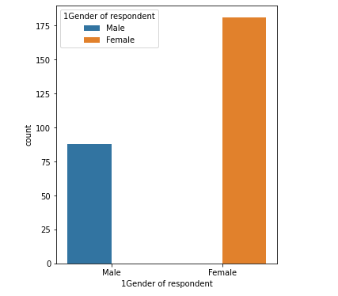

* The data contains about more than 175 records for females and more than 80 records for males.

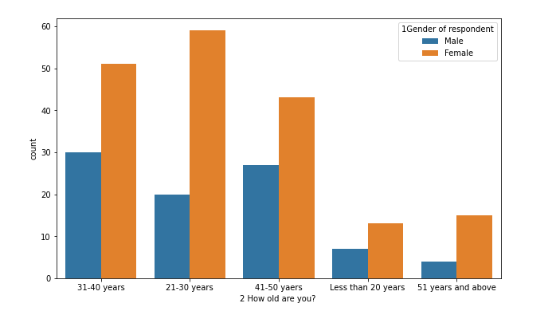

* Most of the individuals that do online shopping are from the age group 2 and 3 which corresponds to 21-30 yrs. and, 31-40 yrs.

Very less number of kids and elderly people prefer e commerce.

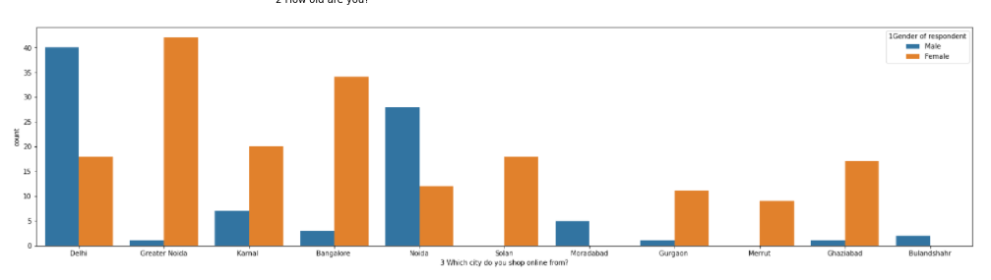

* Even though females are dominant in the dataset, female population using ecommerce is not dominant everywhere

Only 2 cities viz. Delhi and Noida have more males using ecommerce.

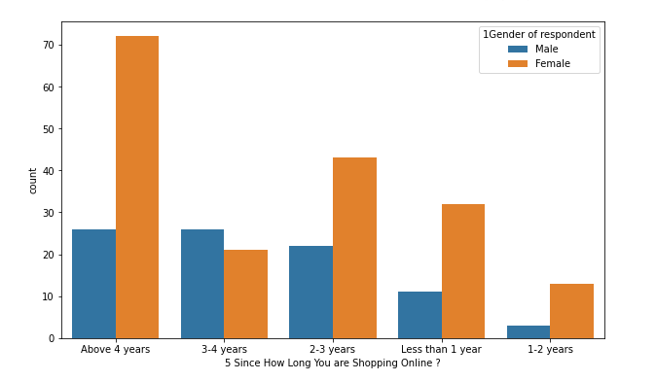

* Amount of females that are shopping since long are more than amount of males.

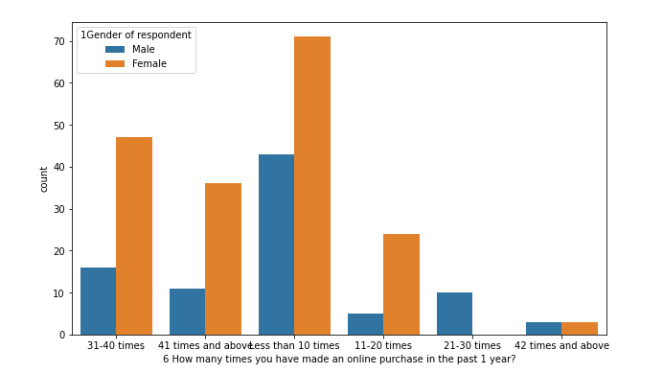

* Frequency of **females shopping online is more** than males which can be inferred from the column ‘how many times you have made and online purchase in the past 1 year’

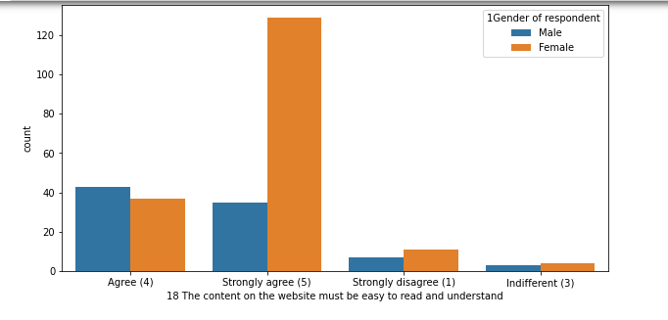

* People have strongly agreed to the fact that the **content on website** must be easy to read and understand

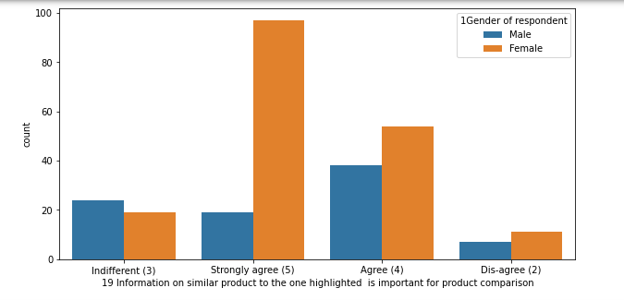

* More females strongly agree with the fact that there must be **similar products to compare**.

Males do agree with the fact but the data suggests that it is **okay if there exists a product but also okay if there does not exist one**.

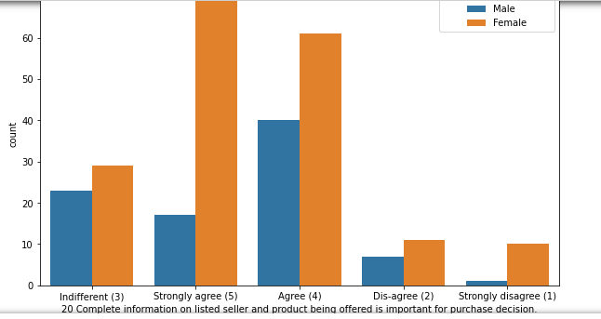

* Maximum people agree with the fact that the **seller information** must be complete and also the **product information** must be proper.

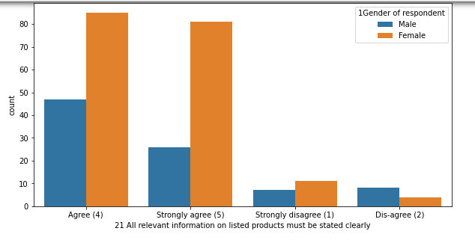

* **Clarity** must be present in the **information** **provided** which is a unanimous opinion

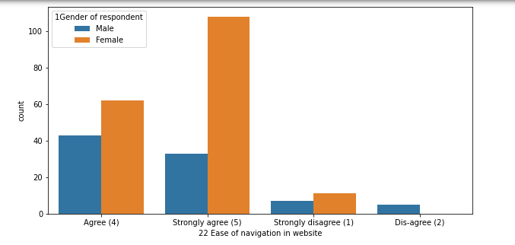

* Similarly the site must be **easy to navigate** is a unanimous opinion

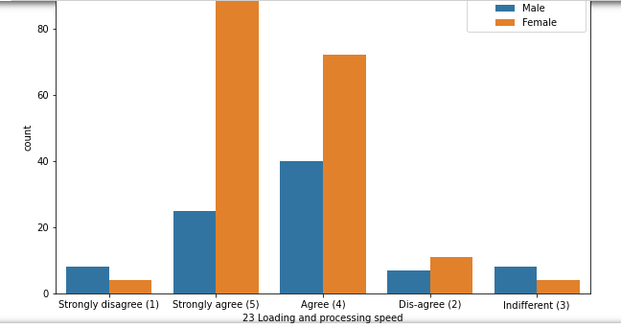

* Both males and females agree that the **loading speed must be high**.

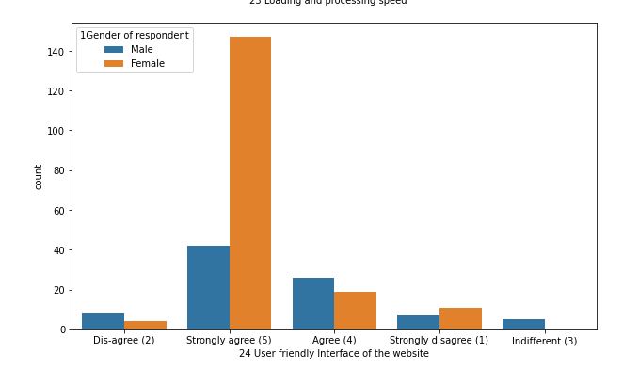

* **User friendliness seems to affect women** **more** or there are less responses by males

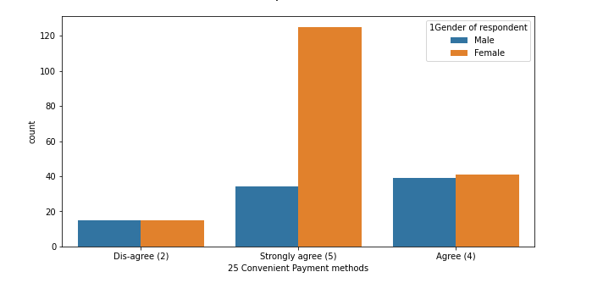

* Maximum people agree that the **payment methods must be convenient**.

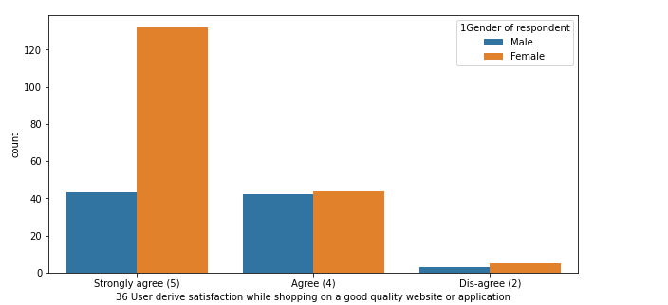

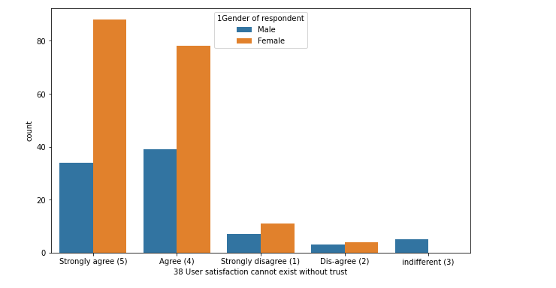

* **Both men and women** agree or strongly agree in majority that **a good website or application leads to user satisfaction**

Observations:

* The data contains about more than 175 records for females and more than 80 records for males.
* Most of the individuals that do online shopping are from the age group 2 and 3 which corresponds to 21-30 yrs. and, 31-40 yrs.

Very less number of kids and elderly people prefer e commerce.

* Even though females are dominant in the dataset, female population using ecommerce is not dominant everywhere

Only 2 cities viz. Delhi and Noida have more males using ecommerce.

In all the other cities, females use ecommerce for shopping more

* Amount of females that are shopping since long are more than amount of males.
* Frequency of **females shopping online is more** than males which can be inferred from the column ‘how many times you have made and online purchase in the past 1 year’
* People have strongly agreed to the fact that the **content on website** must be easy to read and understand
* More females strongly agree with the fact that there must be **similar products to compare**.

Males do agree with the fact but the data suggests that it is **okay if there exists a product but also okay if there does not exist one**.

* Maximum people agree with the fact that the **seller information** must be complete and also the **product information** must be proper.
* **Clarity** must be present in the **information** **provided** which is a unanimous opinion
* Similarly the site must be **easy to navigate** is a unanimous opinion
* Both males and females agree that the **loading speed must be high**.
* **User friendliness seems to affect women** **more** or there are less responses by males.
* Maximum people agree that the **payment methods must be convenient**.
* Varied opinions can be seen in males when trust comes in, but **females strongly** suggest that the online retailer must **assure that the transaction will be completed in time**.
* Everybody agrees or strongly agrees with the fact that **assistance must be top notch**.
* **Distributed opinions** when it comes to **privacy**. Even though maximum people think there must be privacy, the opinions are pretty distributed.
* Everyone expects the **after sales support to be top notch**, women strongly agree that the after sales support must be available, reactions of males are distributed in agree and strongly agree
* **Females strongly agree** that there must be **monetary benefits** and discounts, while a **distribute opinion is observed in males**.
* Change in opinion is observed when asked if they **enjoy shopping online**, where **females enjoyed shopping online** while the response in **males was indifferent.**
* Everyone agrees that shopping online is **flexible and convenient.**
* Males and females both agree that replacement policy is important while they do an online purchase
* **Loyalty programs** are a benefit as per both males and females.
* **Females strongly agree** to the fact that the **information displayed must be quality** on the website and this will lead to customer satisfaction. **Male responses are indifferent** and distributed.
* **Both men and women** agree or strongly agree in majority that **a good website or application leads to user satisfaction**
* Females strongly agree that benefit derived from online shopping leads to customer satisfaction, opinion of males is distributed here
* Females strongly agree with the fact that **user satisfaction and trust are directly proportional**, men too agree with the same opinion
* Both males and females agree to the fact that **variety must be offered** in the product
* Maximum number of people agree with the fact that value for money that they have spent is important and hence the product quality must be according to that, amount of people opting for a strongly agree option is a bit less here
* Males agree to the fact that they feel **gratification** when they shop from favorite retailer.

Women are indifferent ie they do not either strongly agree or strongly disagree with that fact.

* females do not agree with the fact that shopping online helps fulfill certain roles.

Males do agree but not strongly for this.

**CONCLUSION**

Behaviour of females shopping online:

* Females tend to relate factors like trust, empathy more with e commerce.
* There was a factor of enjoyment observed in females
* The quality of content affects more to the female side than male side.
* Females do not agree that shopping online helps fulfil certain roles.
* Females believe that monetary or other benefits lead to customer satisfaction

Behaviour of males shopping online:

* Male opinion was neutral when asked about same factor of enjoyment.
* Quality of content does not affect much.
* Males agree with the fact that they feel gratification when they shop from their favourite retailer.
* Benefits like promotion cards etc are not much effective on the male audience.